Coins in the

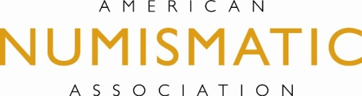
Classroom

Activity
Denomination Dilemma

PURPOSE This activity is designed to help younger students learn how to add using denominations that were used at one time in the United States but are obsolete today.

MATERIALS 1. Several copies of A Guidebook of United States Coins by R.S.
NEEDED Yeoman, edited by Kenneth Bressett.

- Worksheets provided.

INTRODUCTION Explain to students that knowing the correct amount to pay for an item
and making change are two very important skills that people use all of
their lives.

STUDENT 1. Students will be directed to price 5 items. They will then be directed
ACTIVITIES to select the number of coins whose total will match the price for each of the items.

2. The teacher will explain that during the history of the United States, several denominations were used that are no longer used today. The teacher should give examples of different denominations with an explanation of the government’s purpose for creating money of that value. Students will browse through A Guidebook of United States Coins and list all of the denominations that the Mint has produced.

3. Students will complete the second worksheet of obsolete coin values using the same items listed on the original worksheet.

4. The teacher will challenge students to explain the advantages and disadvantages of the obsolete denominations.

Print 1. A Guide Book of United States Coins by R. S. Yeoman, edited by

Resources Kenneth Bressett. Published annually, this is the standard book of coin collectors and contains a wealth of coinage information and an estimate of values.

