Coins in the

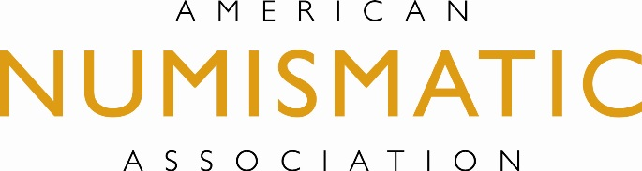
Classroom

Roman Coin Research

Students often fear the word “research”. Research can mean looking for insignificant
facts about an obscure subject. But, what if the research subject was an ancient
coin minted over a thousand years ago that students could hold in their hands?

In this activity, students will conduct an archaeological dig involving ancient coins to
learn about money used in ancient Rome. The great part about this activity is that
your students will not only be able to hold something most likely seen only before in
museums, they will be able to keep the artifact as well. Most students will be
fascinated when holding an ancient coin. When the activity is over and the students
take their coin home, you will have given them the oldest thing that they will probably
ever own in their lives!

PURPOSE This activity is designed for middle and high school educators who are teaching World or Ancient History. Students will learn how Roman money was used.

GOALS At the end of this activity, students will be able to: Conduct an archaeological dig. Attribute an ancient coin and describe how coins were used in Rome.

MATERIALS 1. Roman coins * - Consult local dealers
NEEDED http://www.money.org/membership/dealer-directory.aspx

http://ancientcoinsforeducation.org/

2. Sand

3. Large square or rectangular plastic containers.

4. New pointless pencils.

5. Gallon jug of distilled water.

6. One 35mm plastic film container for each student.

7. String

8. Plastic spoons

9. Mild dish soap

10. Paper plates and paper towels

11. Cotton swabs

12. Tooth brushes

13. Paper cups

14. Map of Roman Empire

PREPARATION 1. Place a layer of sand at the bottom of each large plastic container.

2. Lay out a grid by using the pencils as posts in the sand. Form
the grid pattern by connecting the posts with string. Make sure
that there is a square for each student.

3. Place at least one Roman coin in each of the grids. Carefully
(so as not to disturb the coins) place more sand over the coins
until the level of the sand sits just below the string.
4. On a sheet of paper, number each section of the grid and
assign a student to each section.

You now have your archaeological dig!

Introduction 1. In a teacher directed discussion, challenge students to describe the
duties of an archaeologist. Have the class make a list of steps that
must take place at a successful archaeological dig

STUDENT 1. Have students carefully dig through their section to locate a coin
ACTIVITIES using their plastic spoon.

2. Once they have obtained the coin, have the students complete the Coin Observation Worksheet.

3. Have students view a map of the Roman Empire. Explain how Roman coins were not only a medium of exchange but also served as newspapers by spreading the news of current events depicted on the design of the coin.

4. Students can now begin the attribution process. Pass out cleaning materials to students. Use the paper plates as the platform from where the dirt from the coin will be removed. Pour a small amount of distilled water in the cups. Have students remove the dirt using the following progression:
A. Water and cotton swab
B. Water and toothbrush
C. Soap and cotton swab
D. Soap and toothbrush

This procedure may take more than one class period. Have students label their 35mm canister and place their coins in them for safekeeping.

5. Using the Internet resources students will identify information on their coin and complete the Ancient Roman Coin Data Sheet.

Optional – For high school or advanced middle grade students

Challenge students to identify and research the ruler portrayed on their
coin.

Internet
RESOURCES

Websites: http://www.forumancientcoins.com/dougsmith/uncleaned.html

http://www.forumancientcoins.com/dougsmith/feac71leo.html

http://www.tesorillo.com/aes/home.htm

http://www.wildwinds.com/coins/index.html

http://ancientcoinsforeducation.org/

*Roman coins can be located from several sources. Coins dealers will often sell lower
grade Roman coins to educators for $1-3 per coin. Ancient Coins for
Education, Inc. (ACE) offers teachers a way to obtain ancient coins for student
study and attribution with the help of online and computer resources.

